Regulations:
A14

H.T No

Sreenidhi Institute of Science and Technology
(An Autonomous Institution)
Code No: 4B619 Date: 27-May-2019 (FN)

B.Tech III-Year II-Semester External Examination, May/June-2019 (Supplementary)
DYNAMICS OF MACHINERY (ME)

Time: 3 Hours Max.Marks:70

Note: a) No additional answer sheets will be provided.
b) All sub-parts of a question must be answered at one place only, otherwise it will not be valued.
c) Missing data can be assumed suitably.

Part - A Max.Marks:20

Answer all QUESTIONS.

1. | List out the functions of clutches. | [2M]
2. | Differentiate static and dynamic equilibrium. | [2M]
3. | What is the significance of maximum fluctuation of energy in fly wheel? | [2M]
4. | Define controlling force in governors. | [2M]
5. | List the effects of partial balancing of locomotives. | [2M]
6. | Sketch the Time Vs Displacement for under-damped and over-damped systems. | [2M]
7. | Define friction circle and friction axis. | [2M]
8. | Differentiate governor and flywheel. | [2M]
9. | What is meant by forced vibration? Give two examples. | [2M]
10. | Define gyroscopic couple. | [2M]
Part – B Max.Marks:50
ANSWER ANY FIVE QUESTIONS. EACH QUESTION CARRIES 10 MARKS.

11. | a) | Derive an expression for braking torque on the drum of simple band brake. | [5M]
 | b) | Deduce the expression for the friction moment of a collar thrust bearing, stating clearly the assumption made. | [5M]
12. |  | The lengths of crank and connecting rod of a horizontal reciprocating engine are 200 mm and 1 meter respectively. The crank is rotating at 400 rpm. When the crank has turned 30° from the inner dead center, the difference of pressure between cover end and piston rod is 0.4 N/mm². If the mass of the reciprocating parts is 100 kg and a cylinder bore is 0.4 meters.  Calculate  (i) Piston effort  (ii) Thrust on the side of the cylinder walls  (iii) Thrust in the connecting rod (iv) Crank effort. | [10M]
13. |  | The turning moment diagram for a petrol engine is drawn to a scale of 1mm to 6Nm and the horizontal scale of 1mm to 1°. The turning moment repeat itself after every half revolution of the engine. The area above and below the mean torques line are 305, 710, 50, 350, 980 and 275 mm². The mass of rotating parts is 40kg at a radius of gyration of 140mm. Calculate the coefficient of fluctuation of speed if the mean speed is 1500r.p.m. | [10M]
14. |  | A spring loaded governor of Wilson-Hartnell type is shown in Fig.1. Two balls each of mass 6 kg are connected by two springs. The speed of the governor is 600 rpm in its mean position. The radius of the governor ball is 150 mm. The tension in each of the spring A is 1300 N. Find the tension in the spring B for this position. Find the necessary stiffness of the spring B if the speed is 630 rpm, when the sleeve moves up 20 mm from mean position and if stiffness of each spring A is 10 kN/m.  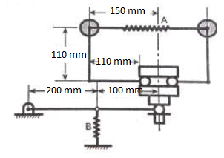  Fig.1 | [10M]
15. |  | A shaft caries four rotating masses A, B, C and D which are completely balanced. The masses B, C and D are 50 kg, 80 kg and 70 kg respectively. The masses C and D make angles of 90° and 95° respectively with mass B in the same sense. The masses A, B, C and D are concentrated at radius 75 mm, 100 mm, 50 mm and 90 mm respectively. The plane of rotation of masses B and C are 250 mm apart.  Determine  (i) the magnitude of mass A and its angular position  (ii) the position of planes A and D. | [10M]
16. |  | The shaft shown in Fig.2 carries two masses. The mass A is 350 kg with radius of gyration 0.8 m and the mass B is 550 kg with radius of gyration 0.95 m. Determine the location of the node and the natural frequency of free torsional vibration of the system. It is desired to have the node at the midsection of the shaft of 120 mm diameter. By changing the diameter of the section having a 90mm diameter, what will be the new diameter. Take C = 84 GN/m².  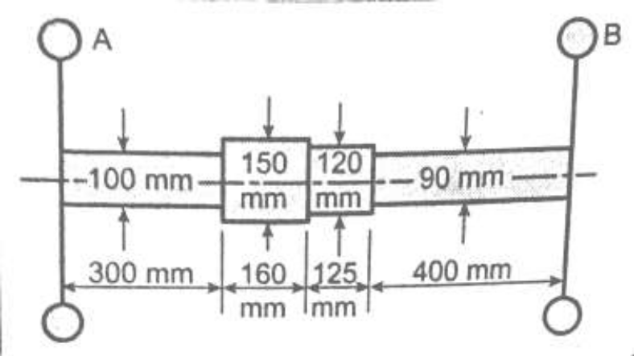  Fig.2 | [10M]
17. |  | The turbine rotor of a ship has a mass of 20 tonnes and a radius of gyration 0.75. Its speed is 2000rpm. The ship pitches 6° above and below the horizontal position. One complete oscillation takes 18 seconds and the motion is simple harmonic.  Determine  (i) the maximum couple tending to shear the holding down bolts of the turbine (ii) The maximum angular acceleration of the ship during pitching  (iii) The direction in which the bow will tend to turn while rising, if the rotation of the rotor is clockwise when looking from rear. | [10M]
18. | a) | Derive the formula for logarithmic decrement. | [5M]
 | b) | A harmonic exciting force of 25 N is acting on a machine part which is having a mass of 2 kg and is vibrating in a viscous medium. The exciting force causes a resonant amplitude of 12.5mm with a period of 0.2 sec. Determine the damping coefficient. | [5M]

-- 00 -- 00 –

